Reviewer name: Adam Fanelli

Project name: Bittorrent GUI Application (BGA)

Presenter: Cornel Stoica

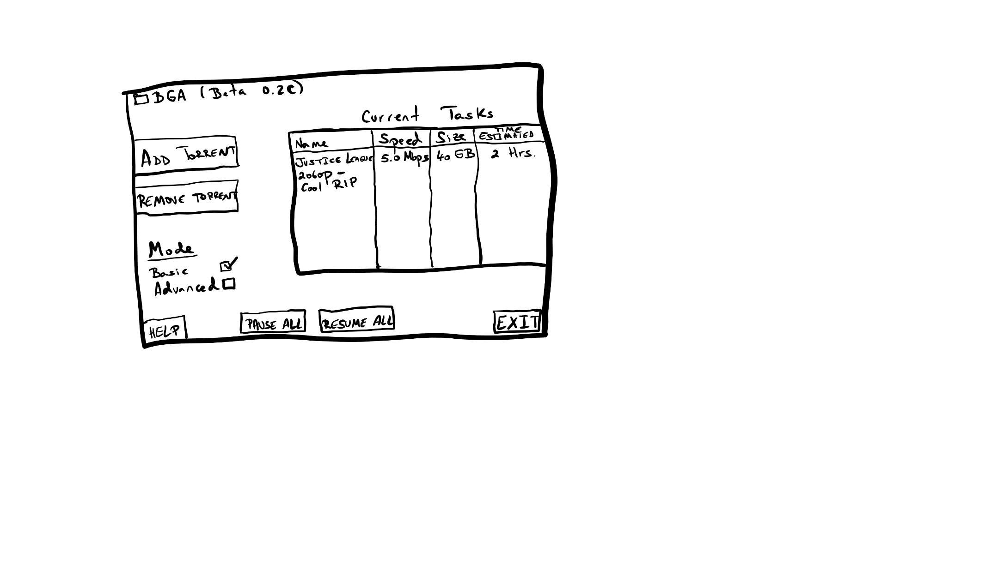

UI Mock-Up:

UI Design Suggestions:

* A way to select and modify individual tasks in the list (listbox style display)
* Some buttons like help and exit might not need to be in the main GUI and could be removed/moved to the header navbar
* Advanced controls could have their own section, maybe one that expands the window when opened